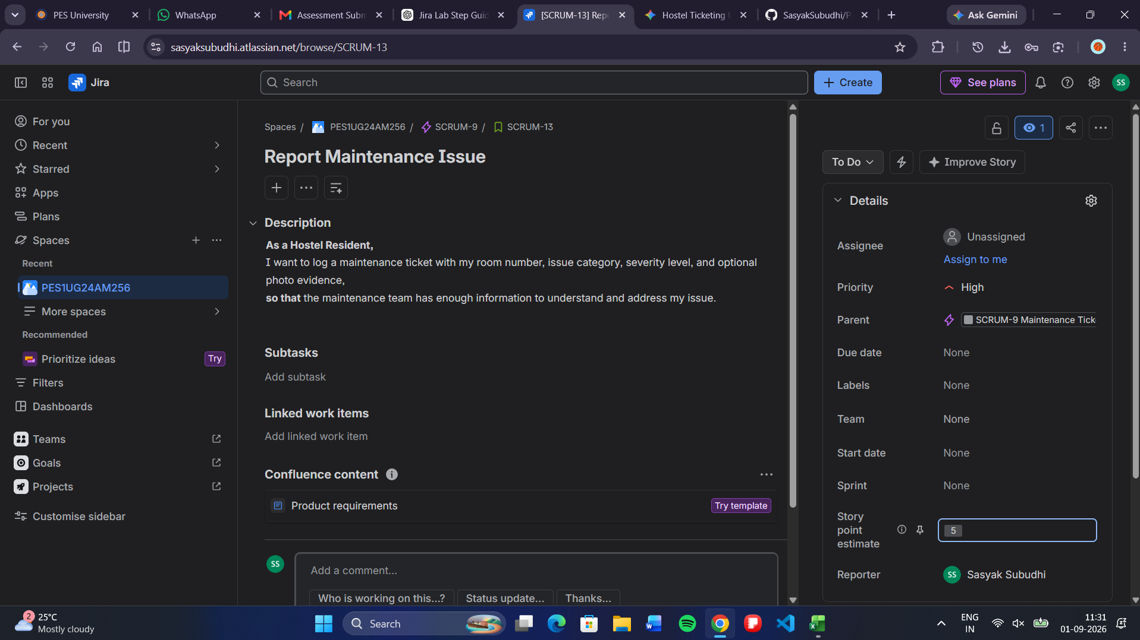
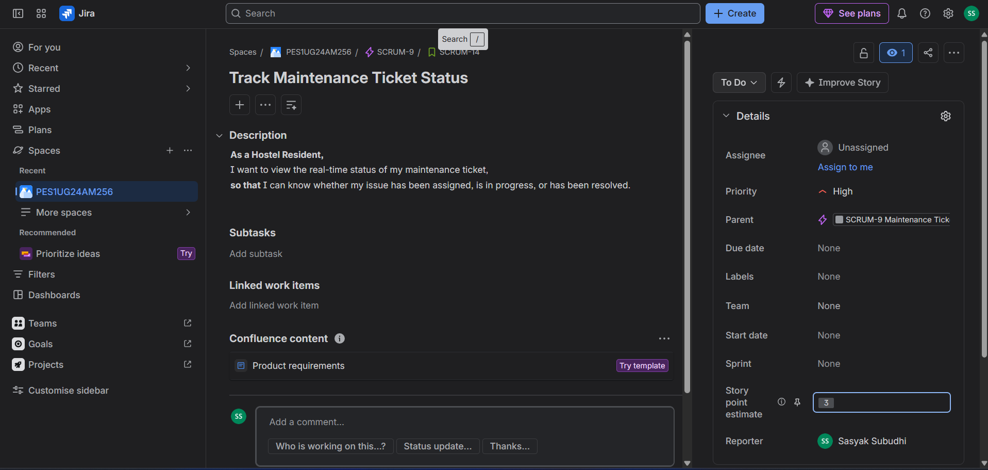
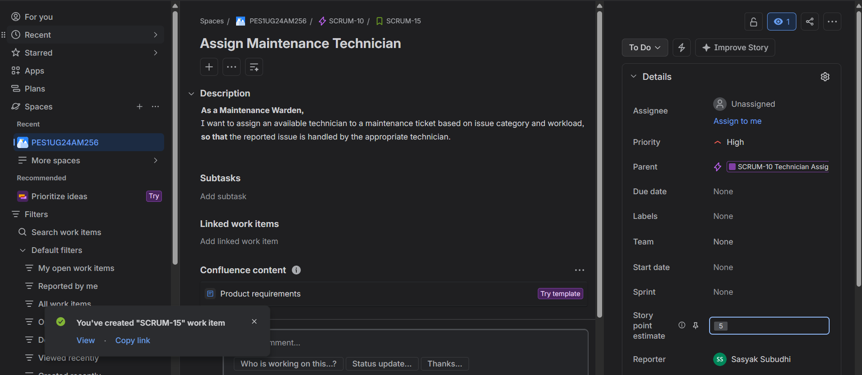
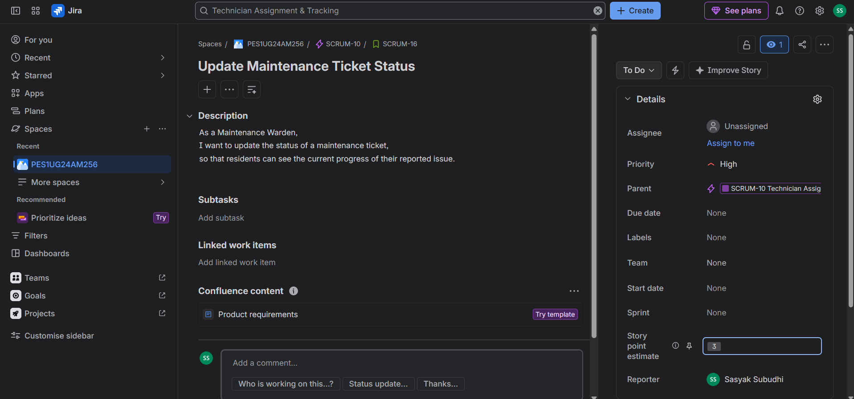
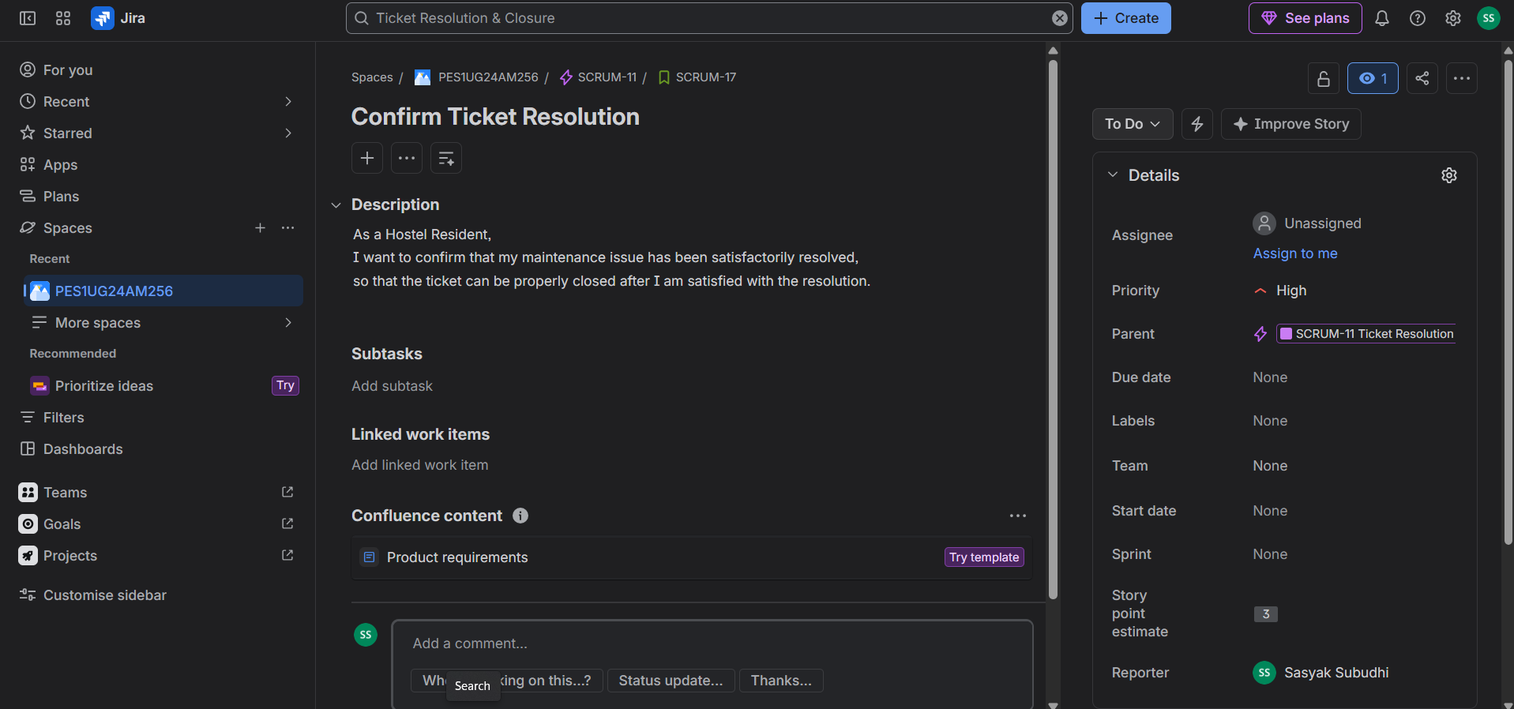
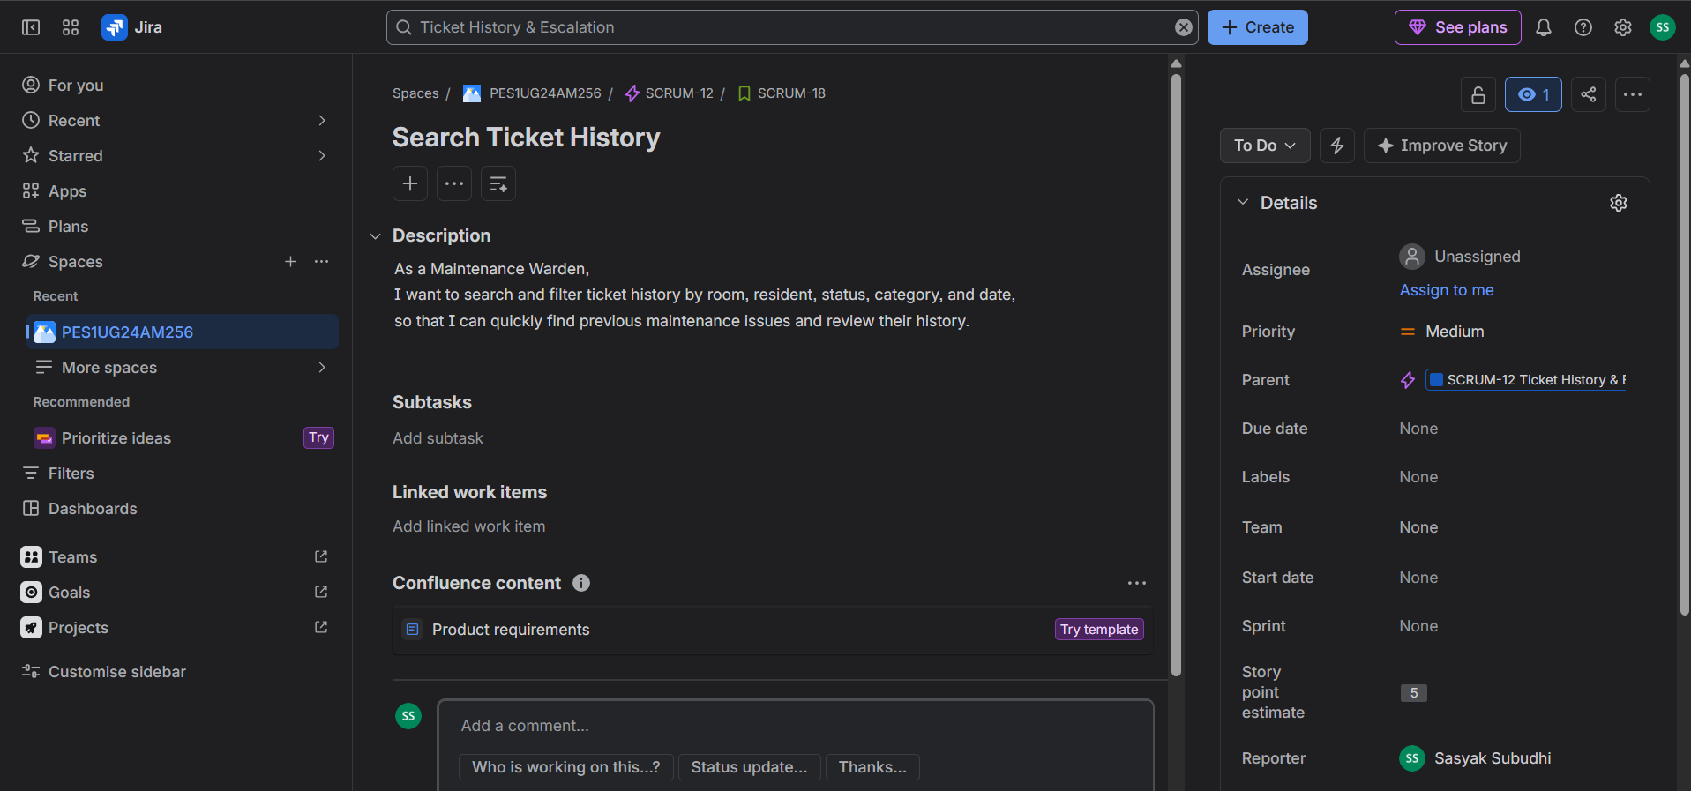
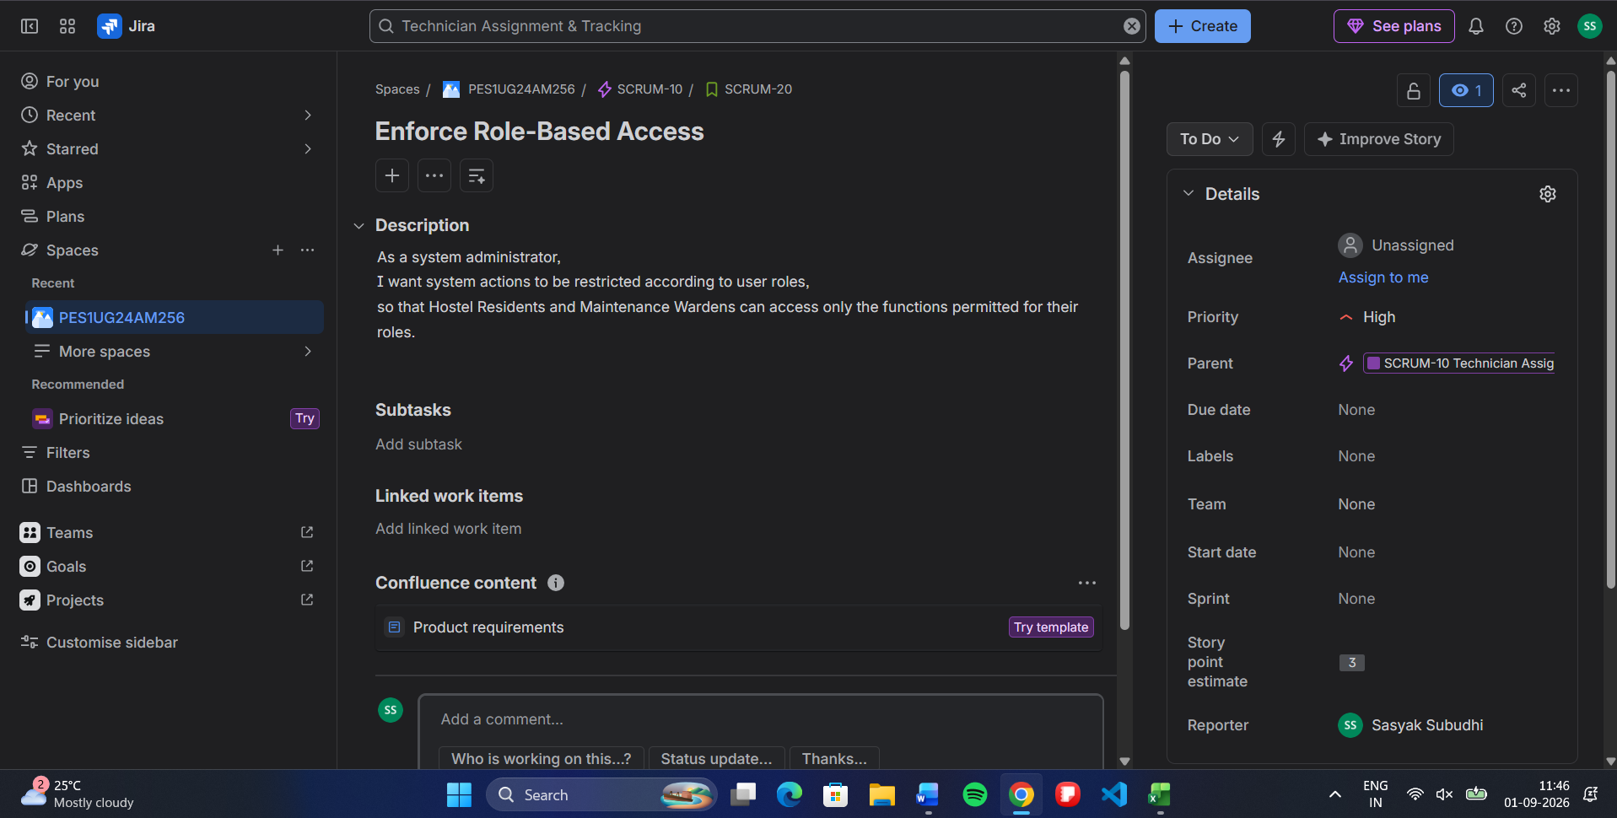
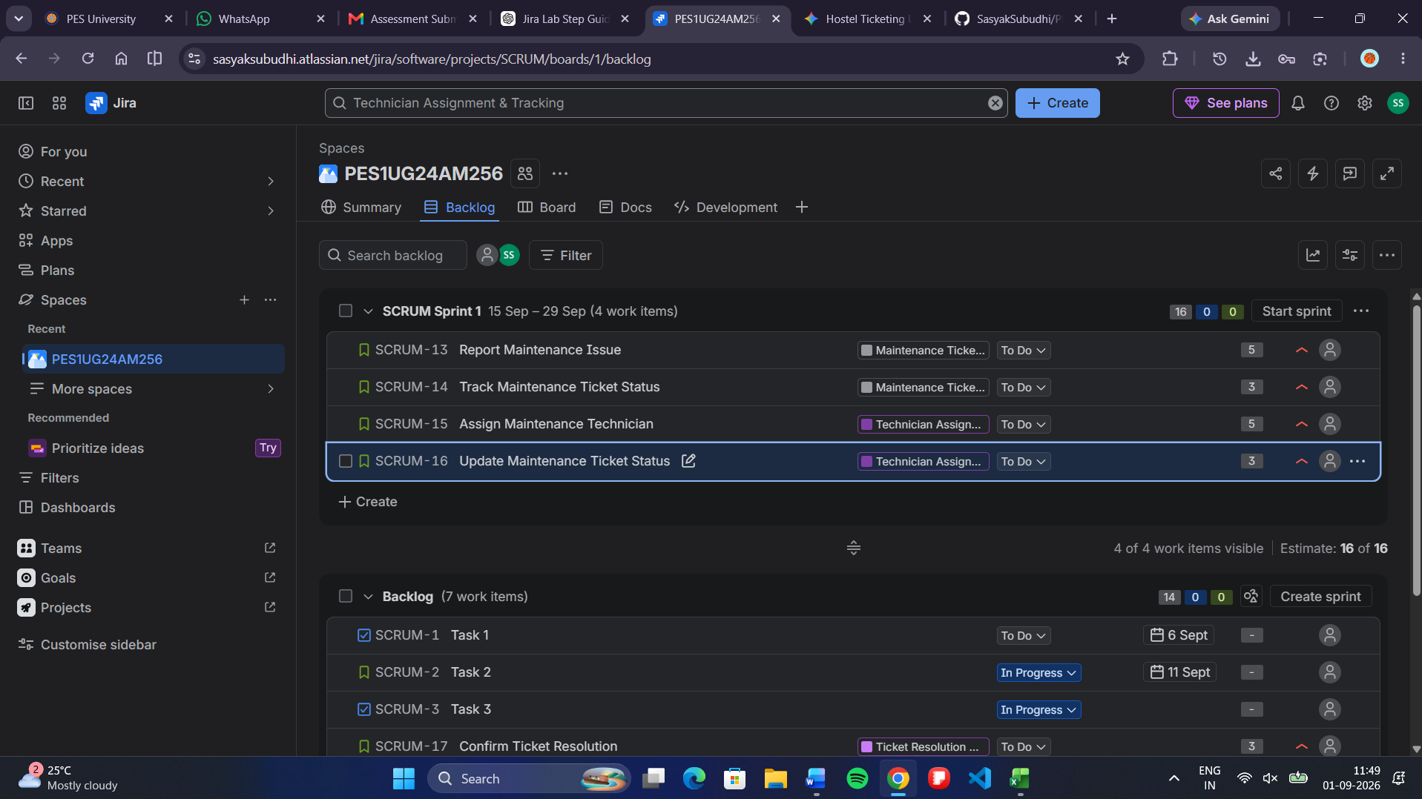
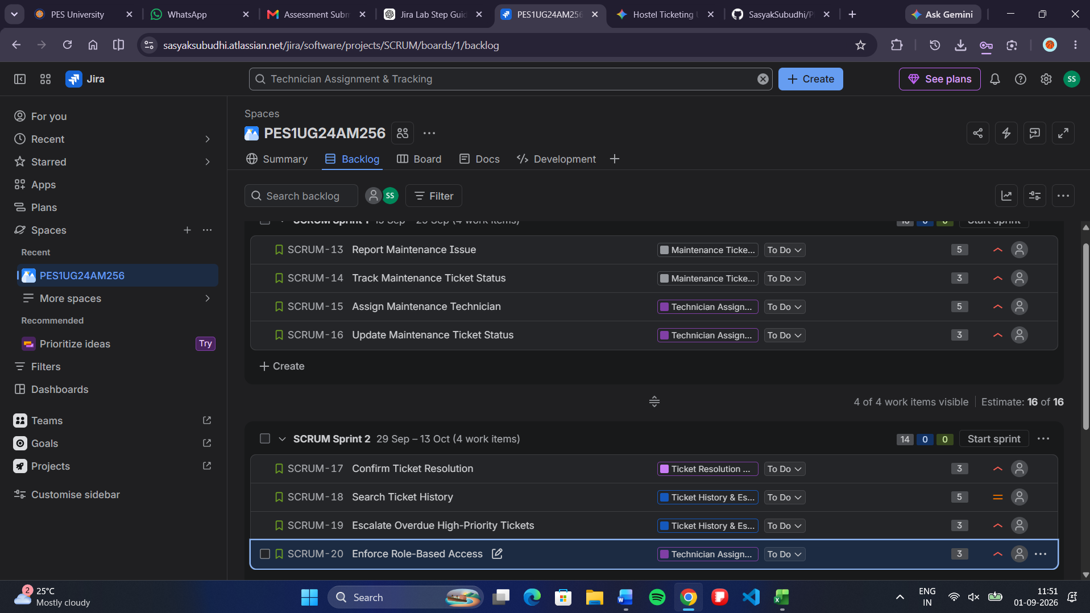
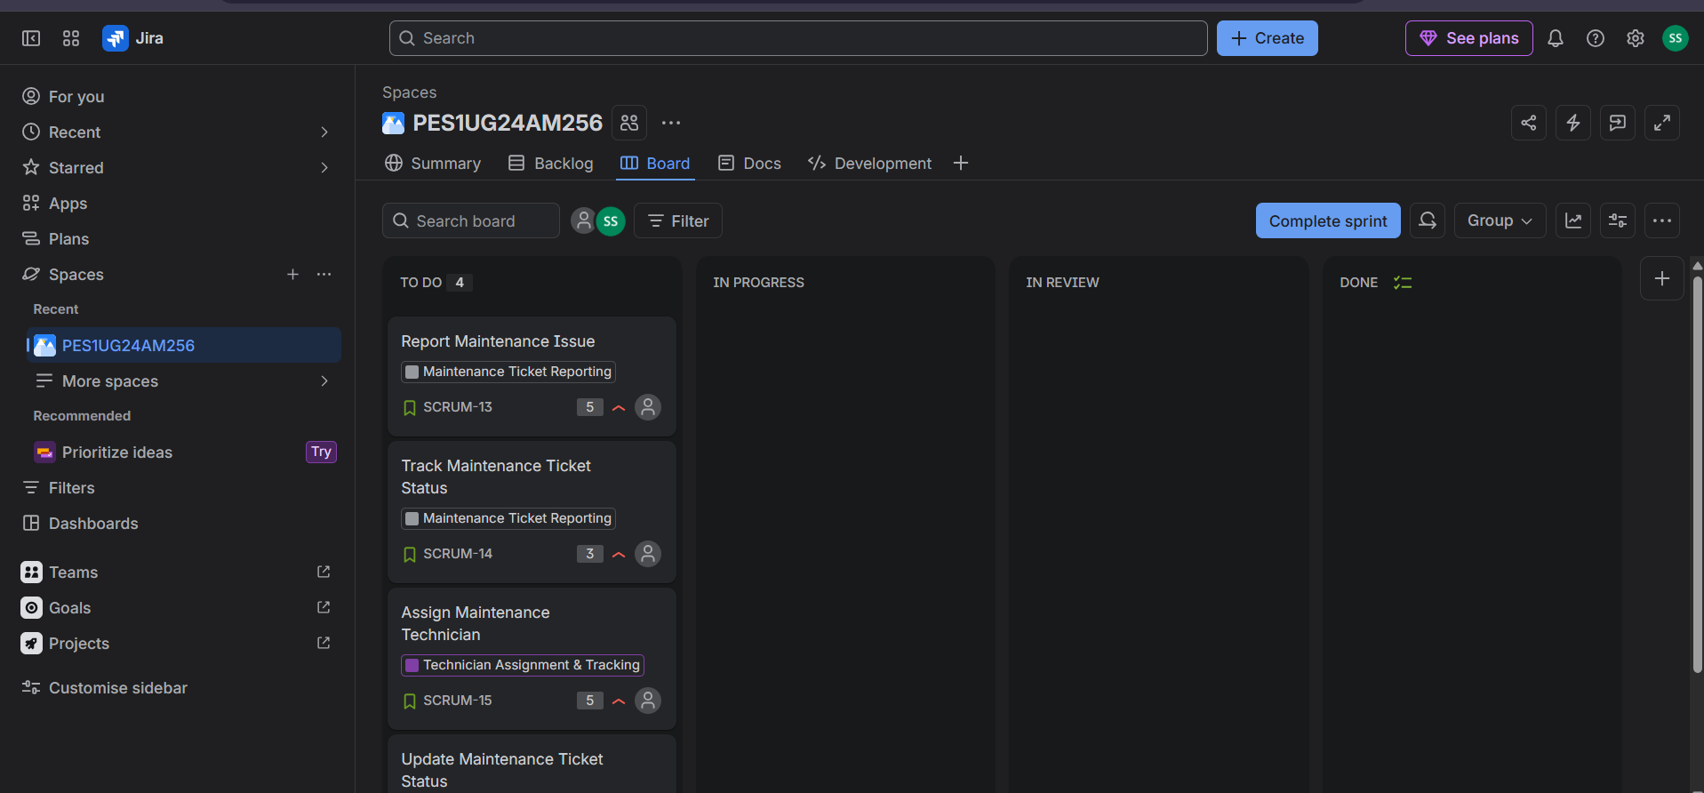
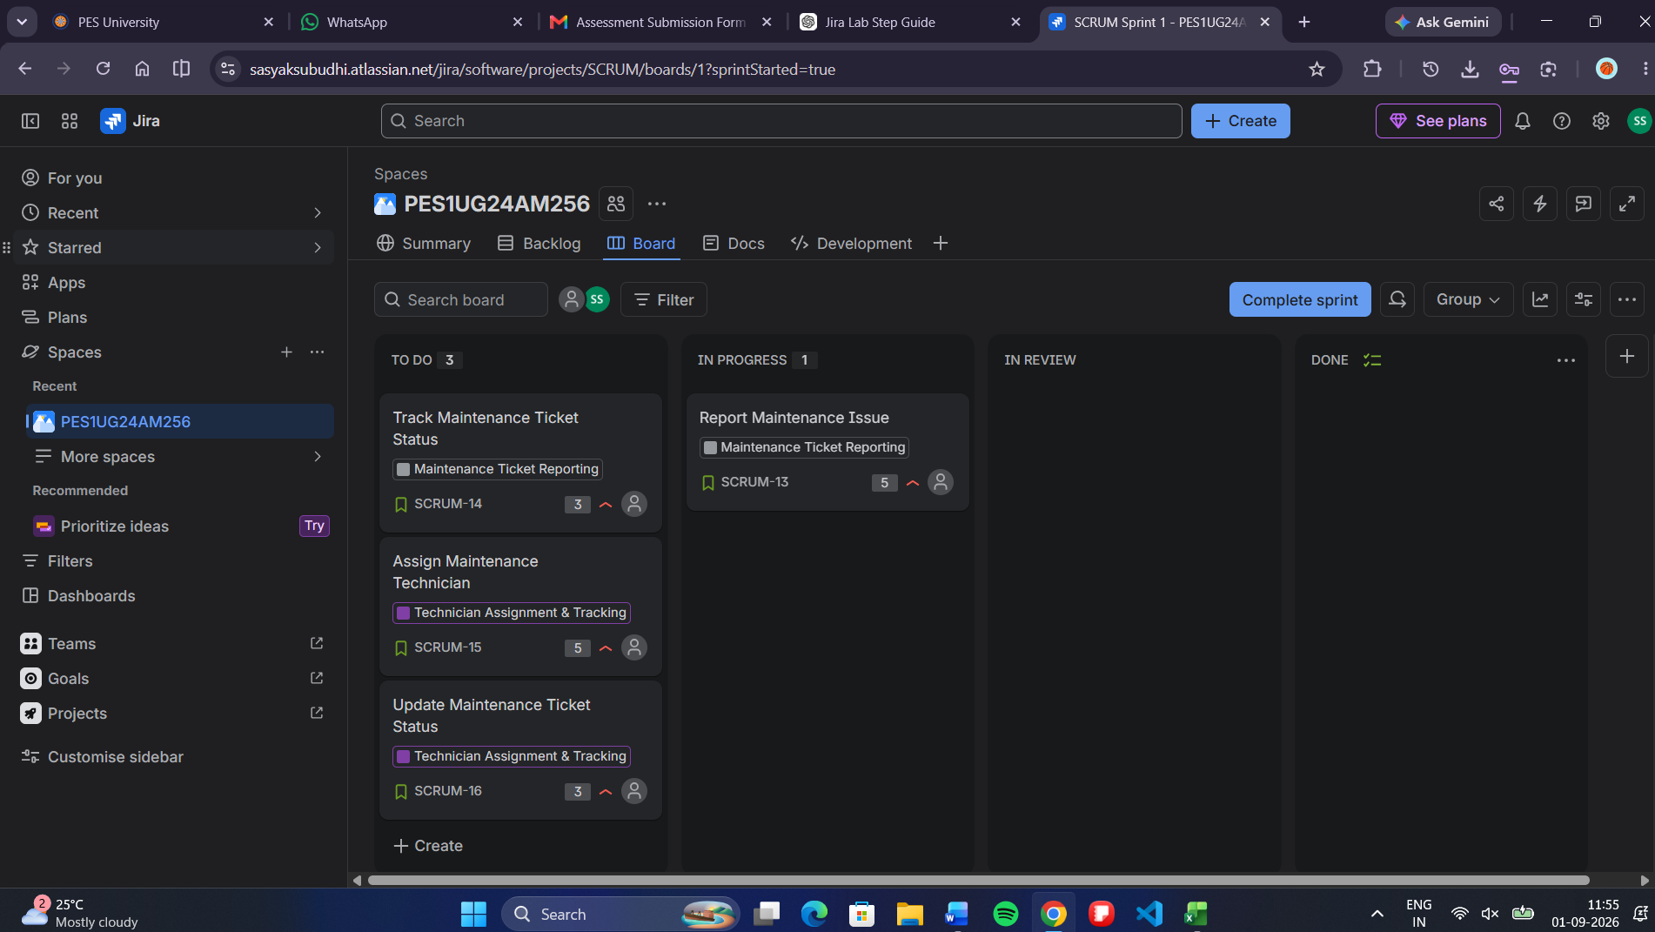
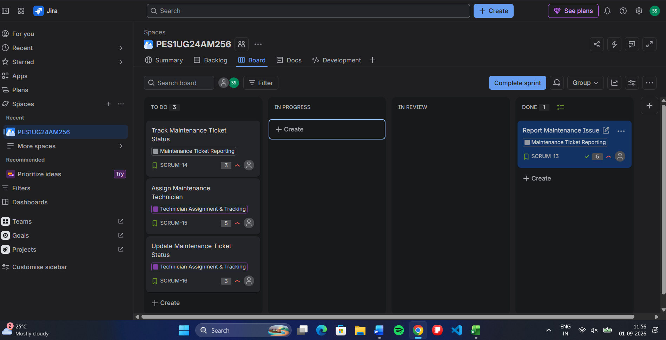
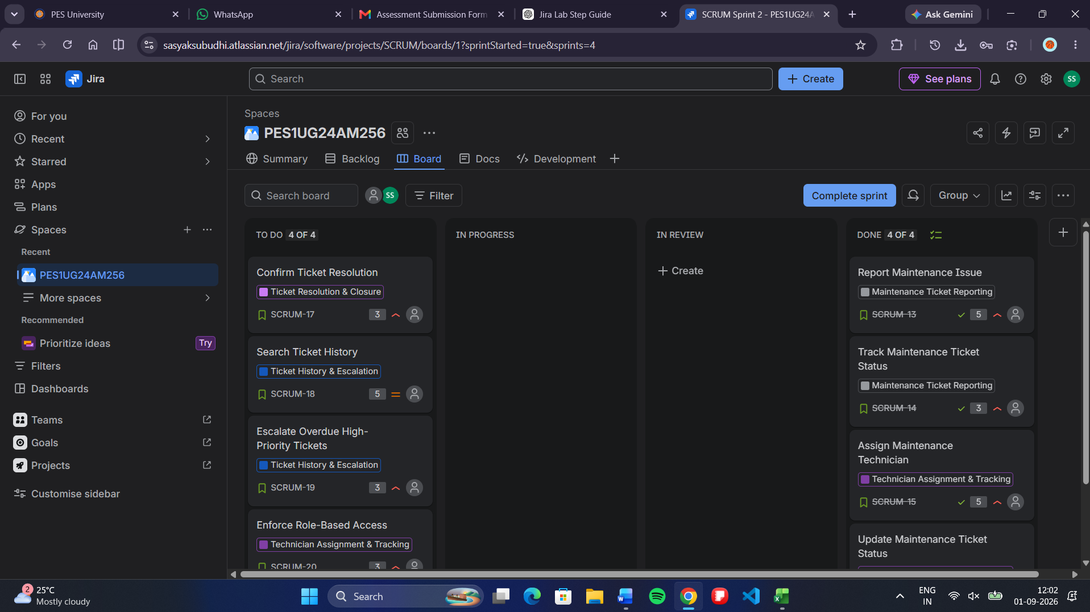
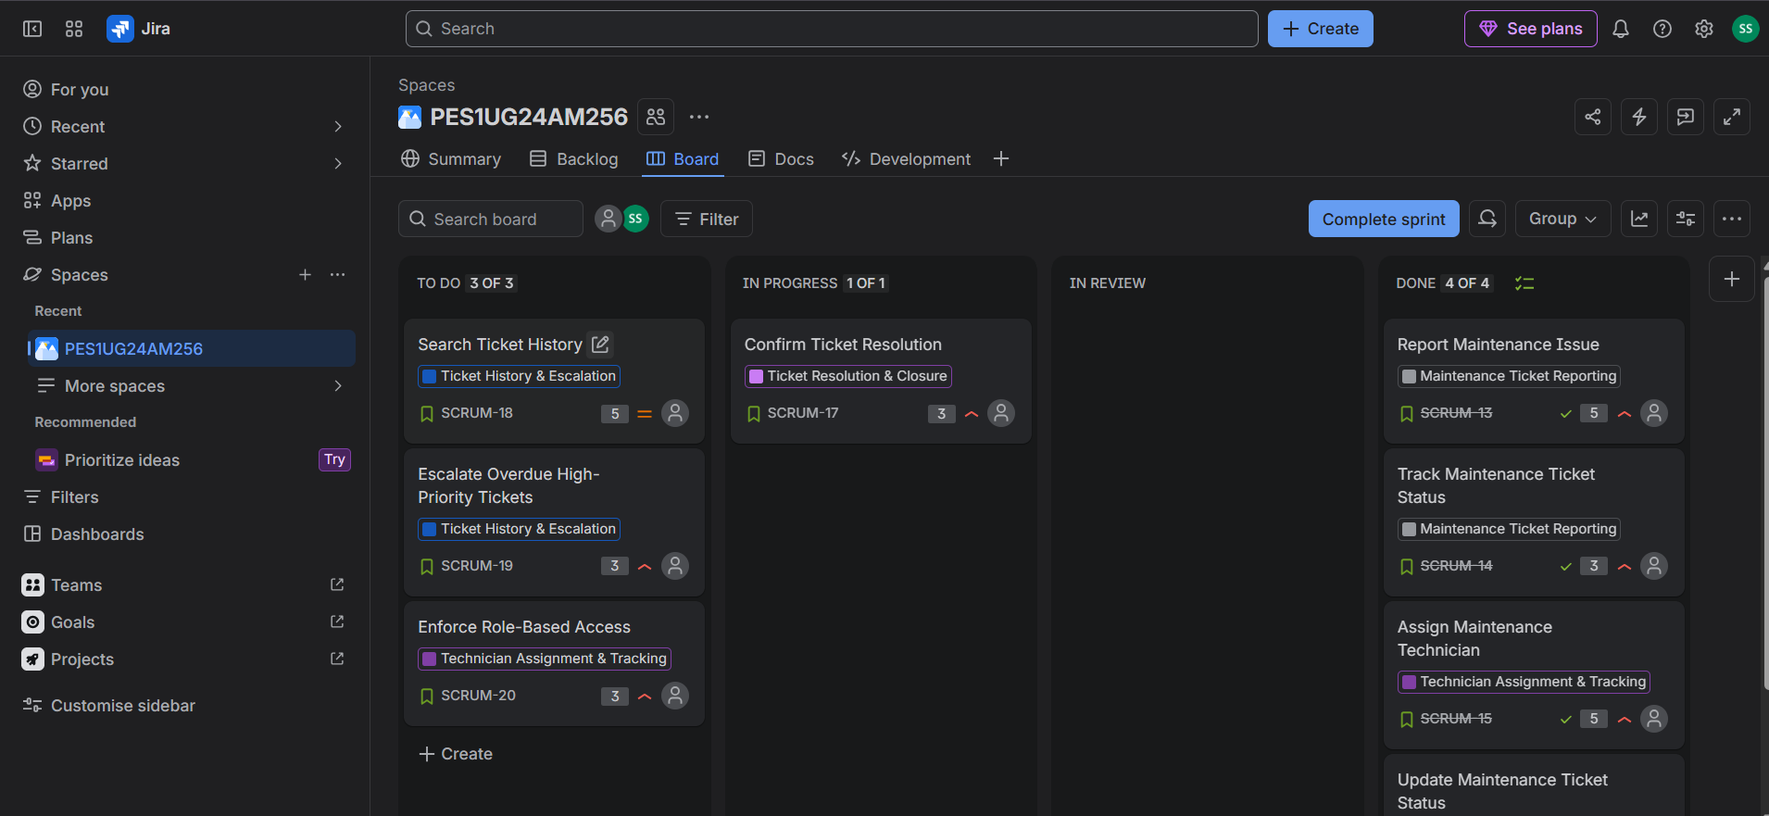
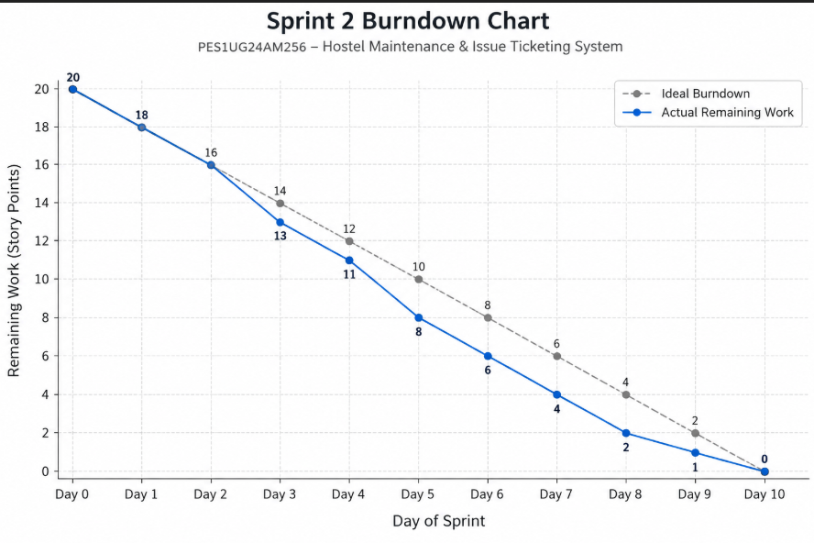
LAB 2 REFLECTION
Agile Backlog Creation & Sprint Simulation in Jira
Project: Hostel Maintenance & Issue Ticketing System
Sprint Summary
Sprint 1 contained 4 stories totaling 16 story points and focused on maintenance issue reporting, ticket tracking, technician assignment, and status updates. Sprint 2 contained 4 stories totaling 14 story points and focused on ticket resolution, ticket history, SLA escalation, and role-based access. All planned stories were completed in the simulation.
1. Did your estimations reflect the actual effort?
Yes, the estimations reflected the simulated effort reasonably well. More complex stories, such as Report Maintenance Issue, Assign Maintenance Technician, and Search Ticket History, were given 5 story points, while more focused tasks were given 3 points. Since this was a simulation rather than a real development project, the estimates cannot be validated against actual development hours, but the relative sizing was consistent with the expected complexity.
2. Was your backlog well-prioritized?
Yes, the backlog was prioritized according to the importance of each requirement to the maintenance workflow. High priority was assigned to core functions such as reporting an issue, assigning technicians, updating ticket status, confirming resolution, SLA escalation, and role-based access. Medium priority was used for supporting functions such as status viewing and ticket history. This ensured that essential workflow features were addressed first.
3. How did your simulated sprint align with your plan?
The simulated sprints aligned closely with the plan. Sprint 1 completed all four planned stories and delivered 16 story points, covering the main reporting and tracking workflow. Sprint 2 completed all four planned stories and delivered 14 story points, covering resolution, history, escalation, and security. Since every planned story was moved through the workflow and completed, the simulation matched the sprint plan successfully.
4. What insights did the burndown chart give about your team's capacity?
The burndown trend showed work decreasing as stories were moved to Done, indicating progress toward completion of the sprint backlog. The simulation completed 16 story points in Sprint 1 and 14 story points in Sprint 2, suggesting a simulated capacity of roughly 14–16 story points per sprint. The key insight is that tracking remaining work against time helps determine whether the team is progressing at a suitable pace and whether the planned workload is realistic.
Conclusion
Overall, the Jira simulation demonstrated how a prioritized backlog, story-point estimation, sprint planning, task status tracking, and burndown analysis work together in an Agile process.

